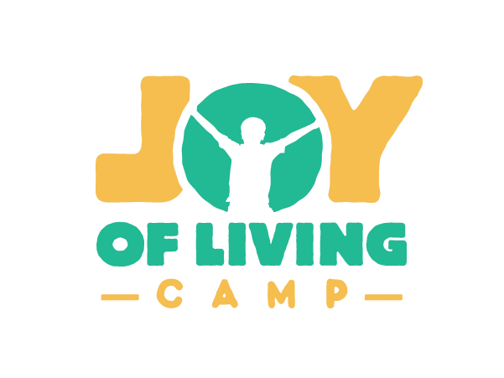
Position: Summer Camp Counselor
Job Definition: A Camp Counselor is someone who guides and ensures the safety of children as they engage in camp activities. They assist with activity planning and receive special training to fully support kids' needs during their stay at the camp.

Reporting Structure: This position is under the direct supervision of the Summer Camp Director and works closely with the summer camp counselors, Facility Director, and volunteers. Ultimate direction/supervision is given by the Executive Director and Board.

Essential Duties: Summer Camp Counselor
- Building relationships with campers as you lead them throughout the day.
- Strong emphasis on discipleship and having fun.
- Leading recreational and educational activities (such as swimming, crafting, ropes courses).
- Ensuring camping equipment is used correctly.

Requirements and skills –
- Patient and reliable
- strong communication skills
- Must be a team player and willing to work with others
- A love for children
- Energetic and positive
- Ministry minded with a desire to serve kids and parents
- Ability to meet the physical demands of the job (strength and stamina to follow strenuous activities like hiking, running, crouching or carrying children)

